Part 1

- The following question is about magnets.
- Iron is a magnetic material.
Name two other magnetic elements. (2)

- Describe the effect a permanent magnet will have on an induced magnet. (1)

- Describe how a piece of iron can be made an induced magnet. (1)

- Describe how an induced magnet can be demagnetised. (1)

- A student is asked to find the magnetic field pattern of a permanent bar magnet.
Describe two methods the student could use to find the magnetic field pattern of the permanent bar magnet. You may draw a diagram to help answer this question. (4)

- Explain how the student can determine where the magnetic field is strongest from the magnetic field pattern. (2)

- The Maglev train floats over its track using an electromagnet. Maglev trains have managed speeds in excess of 370 mph. A model of the Maglev train uses two permanent magnets to get the model to float over the track.
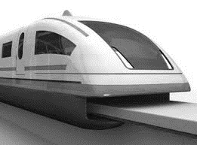
- Describe how the magnets must be arranged to get the model Maglev Train to float. (2)

- Suggest an advantage of using the Maglev train compared to conventional trains. (1)

Part 2
- Electric motors have many uses in the home.
- Give two uses of electric motors in the home. (2)

- Draw and label a diagram of a simple motor (4)
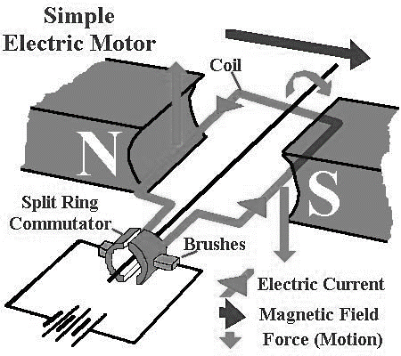

- State three changes that you could make to get the motor to spin faster. (3)

- Give two changes that you could make to get the motor to reverse its direction of rotation. (2)

- Figure 1 shows an electric bell. Electric bells are used in fire alarms.

- Explain how the electric bell works. (4)
Figure 1
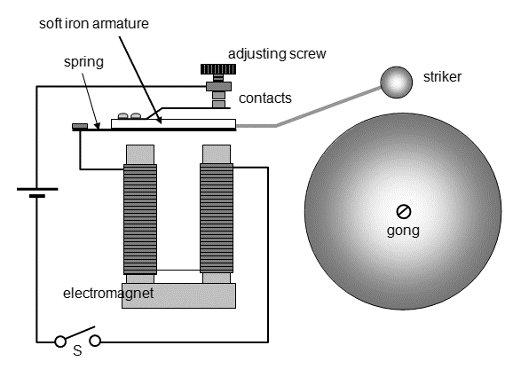
- Inside an electric bell there is a coil of wire called a solenoid.
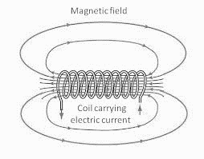
Draw the magnetic field pattern for a solenoid. (2)

S
N

- One method of making the magnetic field of the solenoid stronger is to increase the number of turns of wire on the solenoid.
Describe two other ways of making the magnetic field of the solenoid stronger. (2)

- Electric bells are one use of electromagnets. Suggest two other uses of electromagnets. (2)

- A straight wire carrying an electric current (I) is placed between two magnets, as shown in Figure
2. (HT)
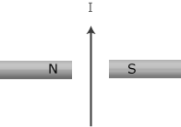
Figure 2

- The wire experiences a force. In which direction will the force act? Explain your answer. (2)
- Explain why the wire will experience a force. (3)

- The length of wire between the magnets if 4 cm and carries a current of 0.6 A. Work out the size of the force on the wire if the magnetic field strength is 0.05 T. (2)

force = magnetic flux density x current x length

- Figure 1 shows a generator. The generator is rotated by a handle and there is an alternating current output produced.
Figure 1

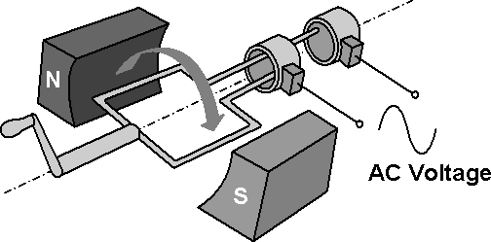

- Explain why the output of the generator, shown in Figure 1, is an alternating current. (5)

- As the coil of wire in the generator spins, an output potential difference is induced.
Explain how the size of this induced potential difference varies as the coil of wire spins. (4)

- Spinning the handle of the generator faster gives a greater induced potential difference.
Explain why rotating the handle faster gives a greater induced potential difference. (3)

- Suggest one other way of getting a greater induced potential difference. Give a reason for you answer. (2)
- Figure 2 shows a cross section of a microphone.
A microphone can be used to record sound onto a hard drive.
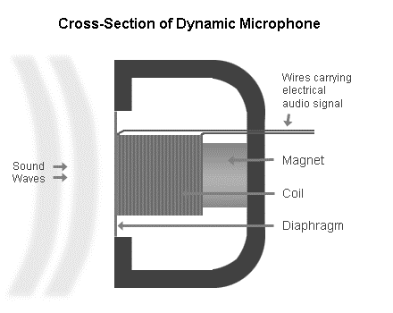
Figure 2

Explain how a microphone can be used to record sound onto a hard drive. (4)

- A step-down transformer is used in The National Grid to reduce the potential difference from 400,000 V to 15,000 V, before being further reduced to 230 V for use in the home.

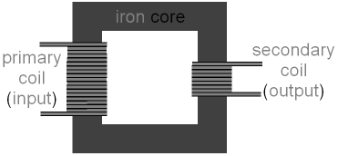
- Describe the construction of a step-down transformer. You may draw a labelled diagram to help you answer this question. (3)

- A step-down transformer can be used to charge laptop computers. A 230 V laptop computer charger has 600 turns of wire on the primary coil and 50 turns of wire on the secondary coil. Work out the output potential difference on the laptop charger. (3)

- The current in the secondary coil of the laptop charger is 5A.
Work out the current in the primary coil of the laptop charger. (2)

- Explain why transformers are used in The National Grid. (4)

- Explain how a transformer works. You may draw a diagram to help answer this question.

